**Lecture 2 Notes**

Use player instead of “user” when writing the use cases.

Use cases are only things you can do to change the state

Solve planar puzzle & extend color are almost the same. The exit criteria is just different

Don’t need to add the unselect use case

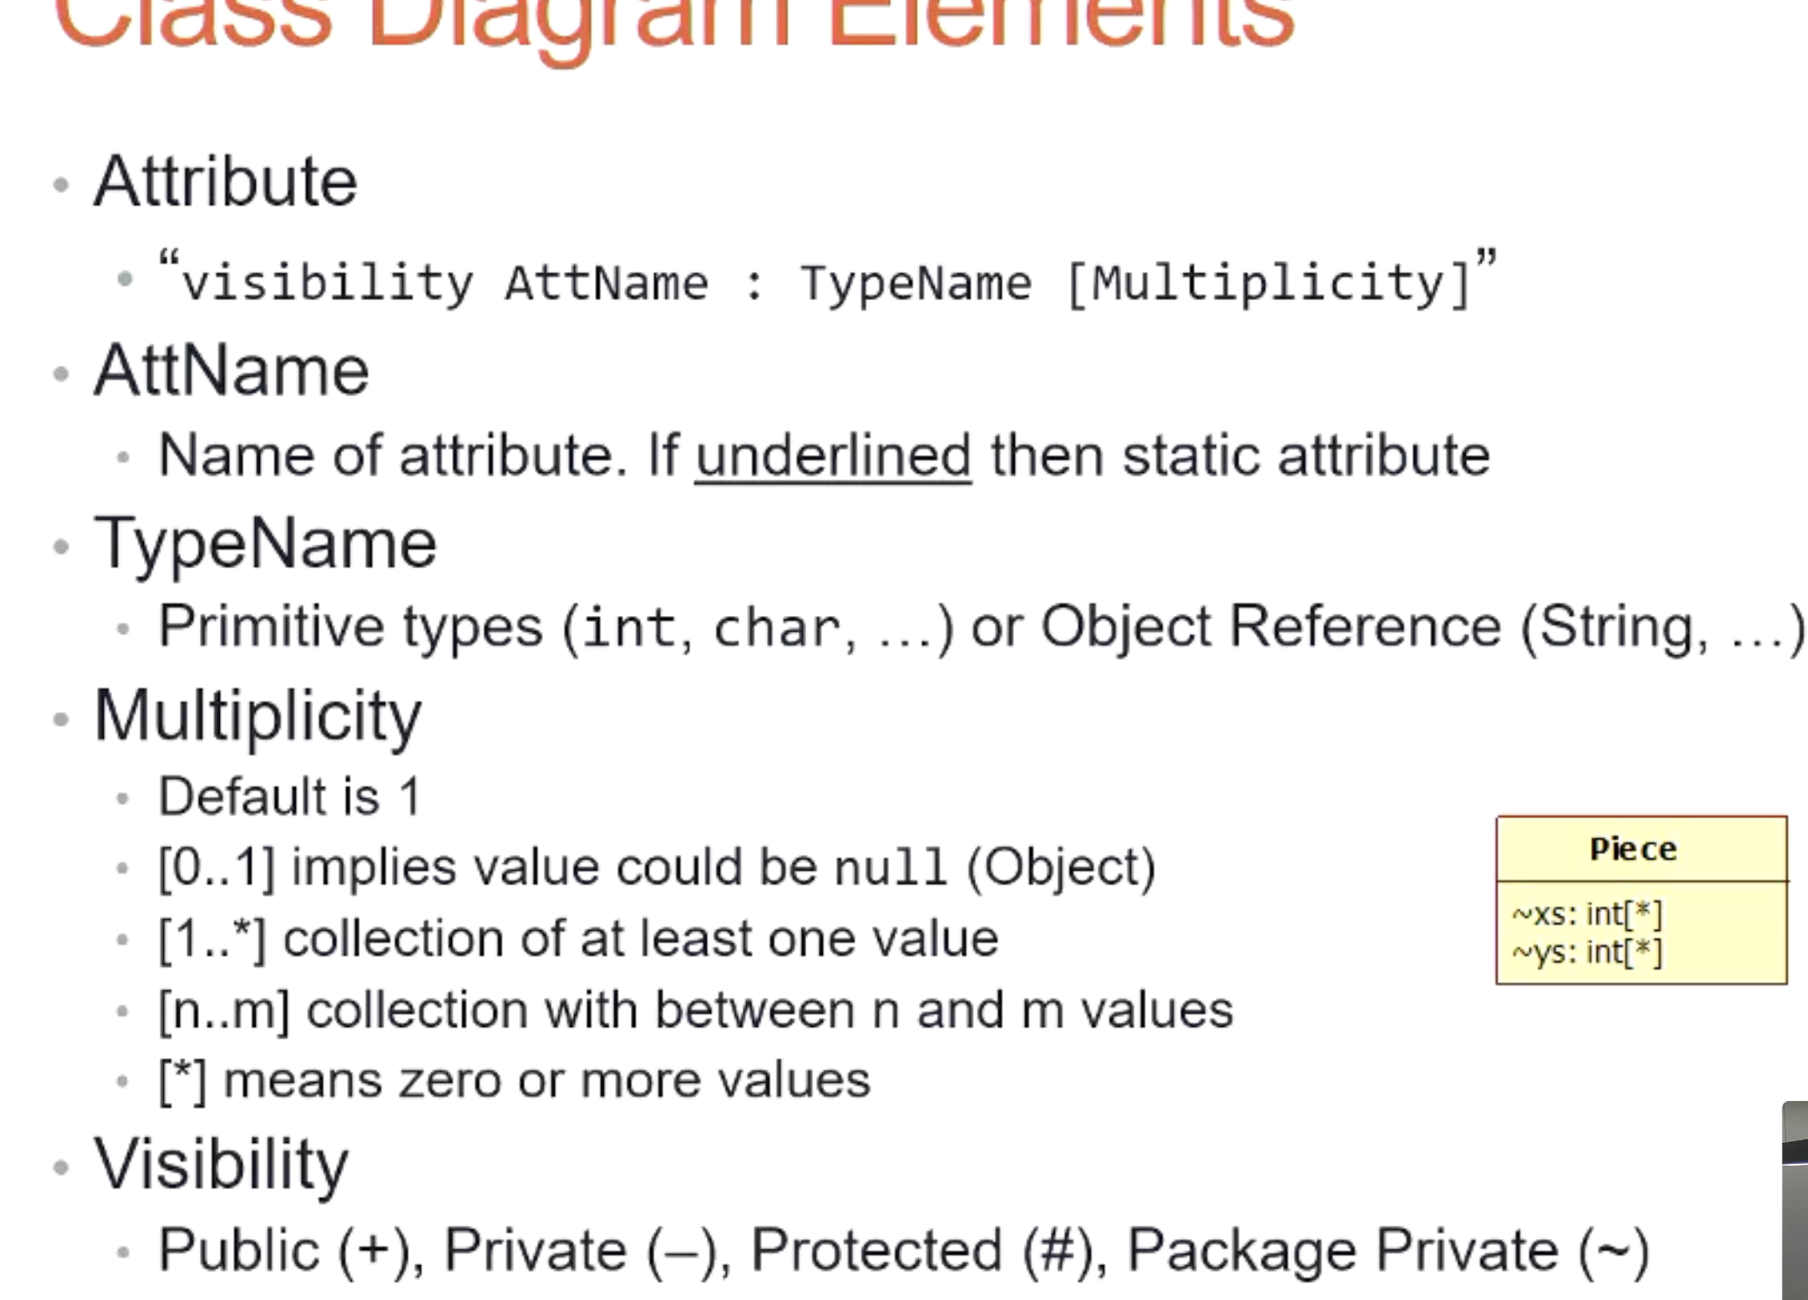

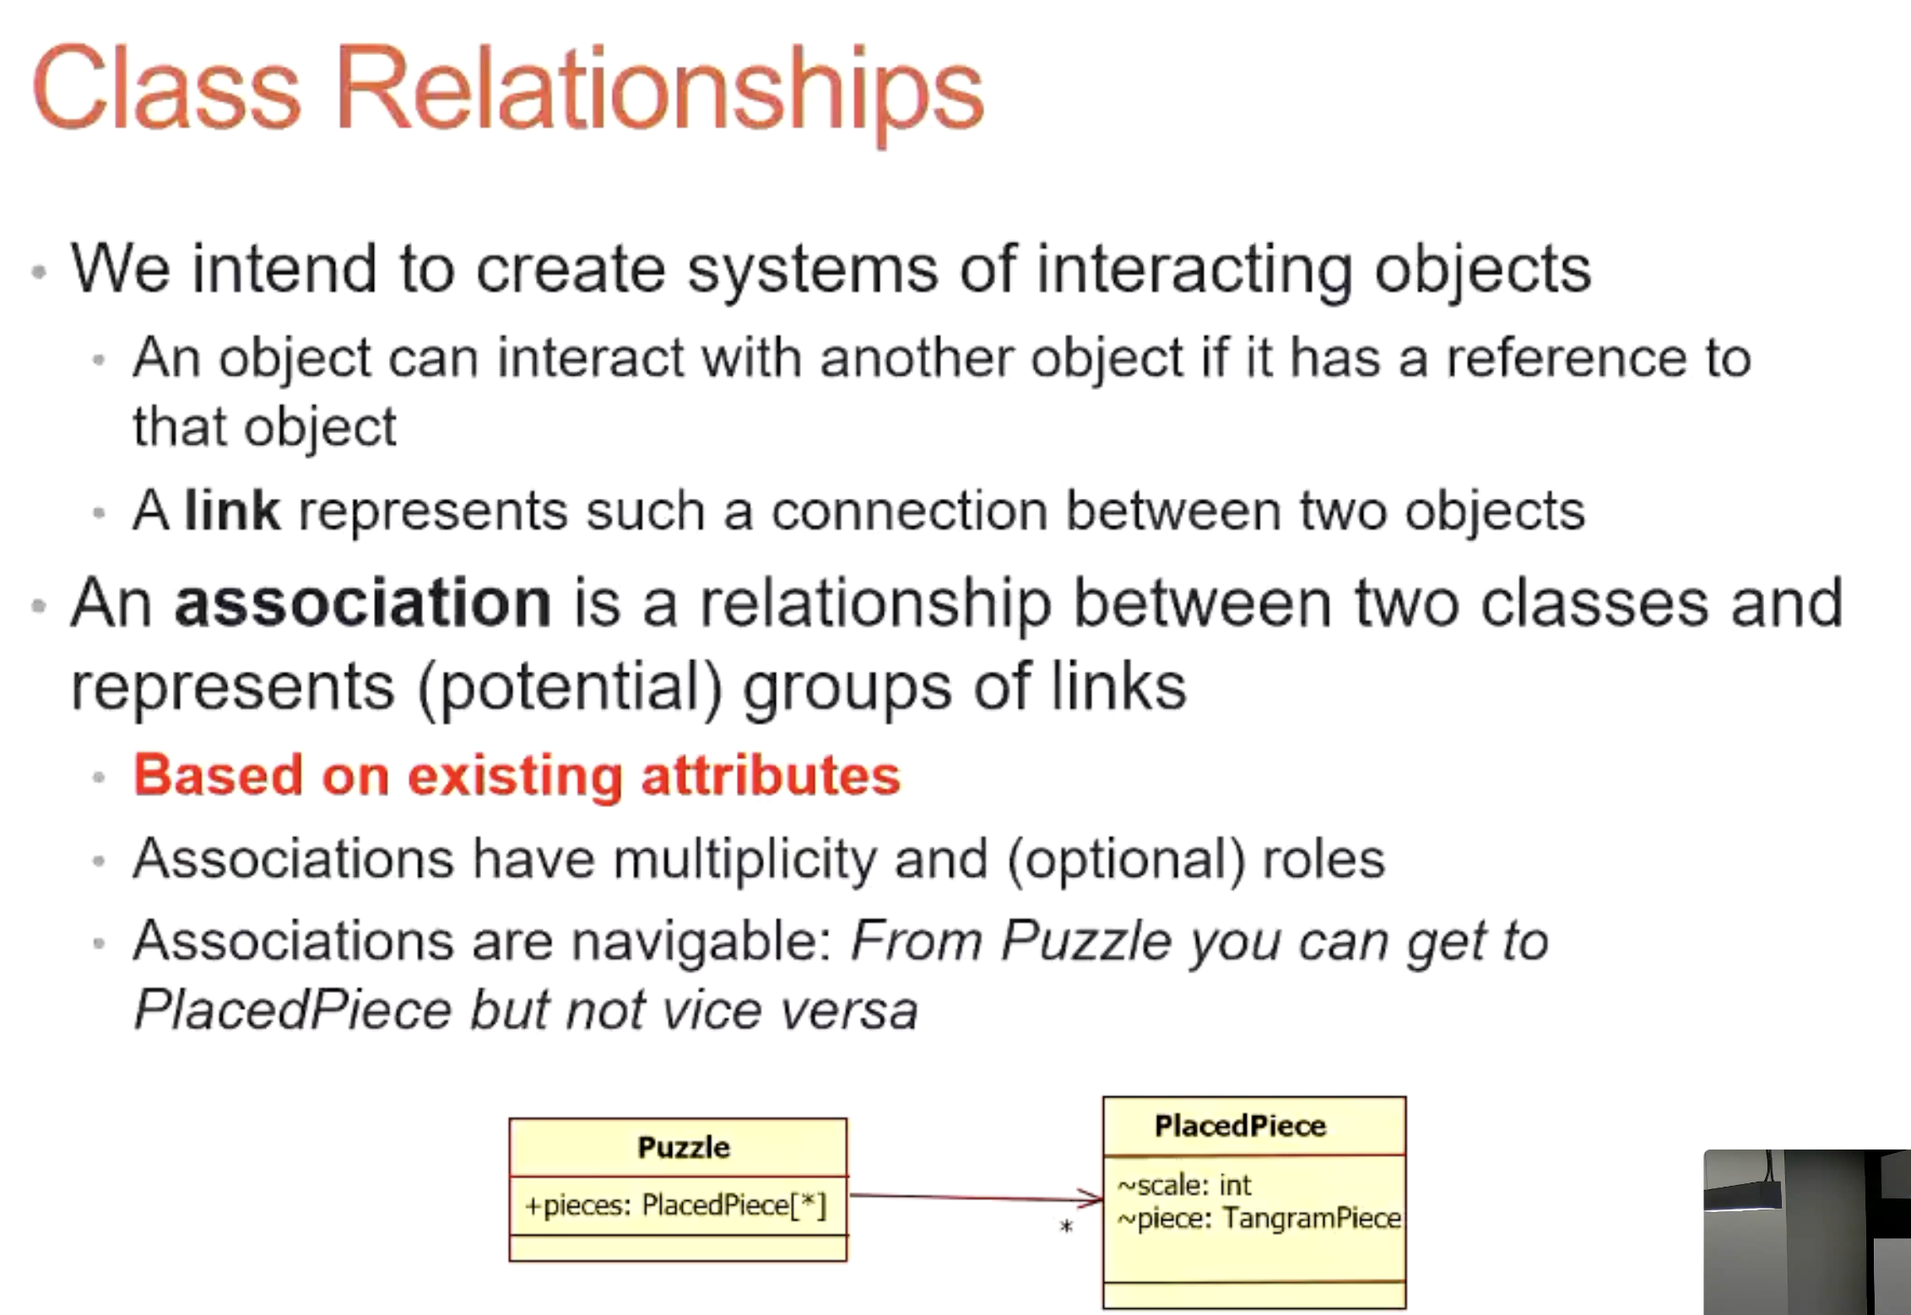

**This next class relationship is barely used but when it is, its intentional**

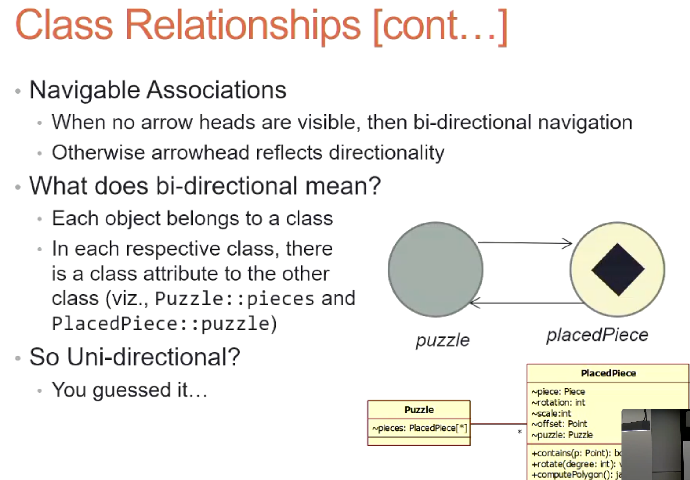

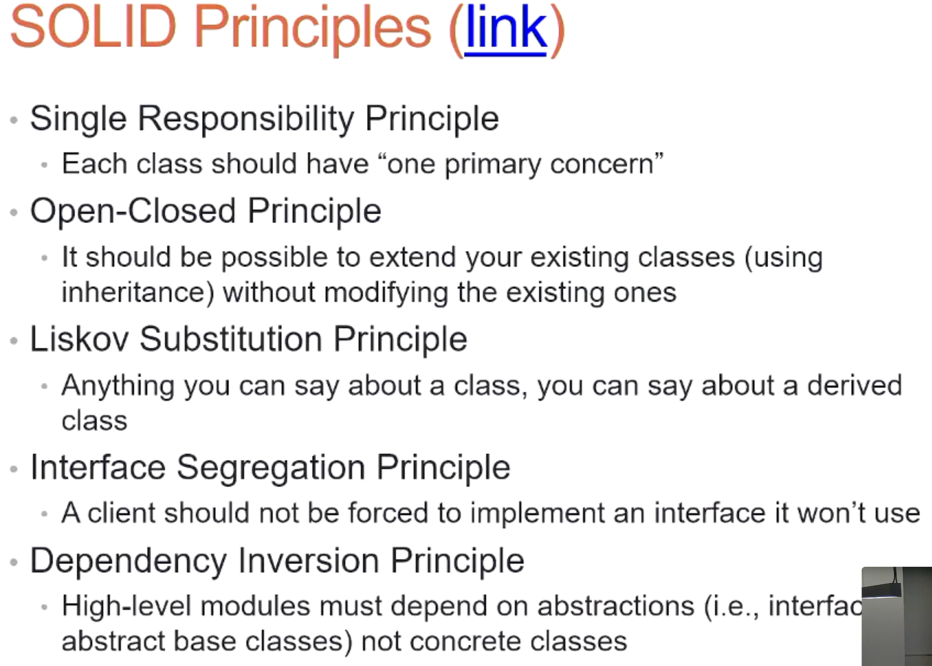

This next one could be on the final exam

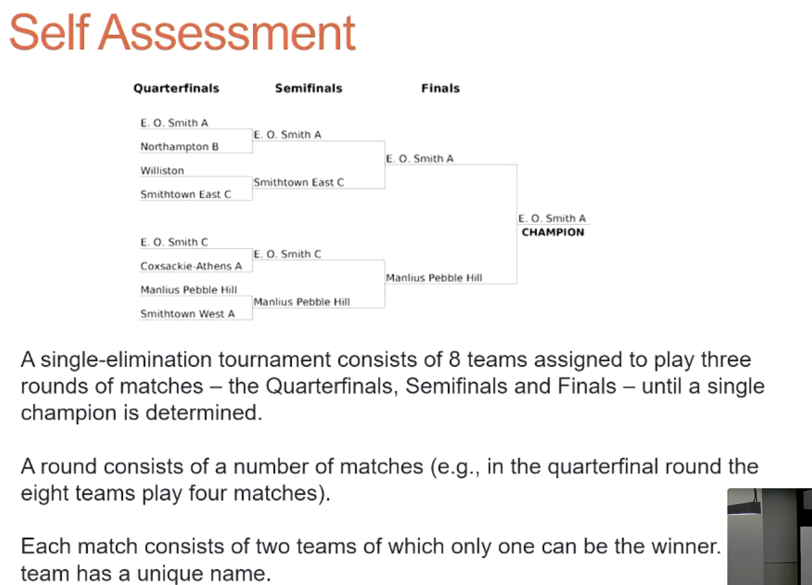

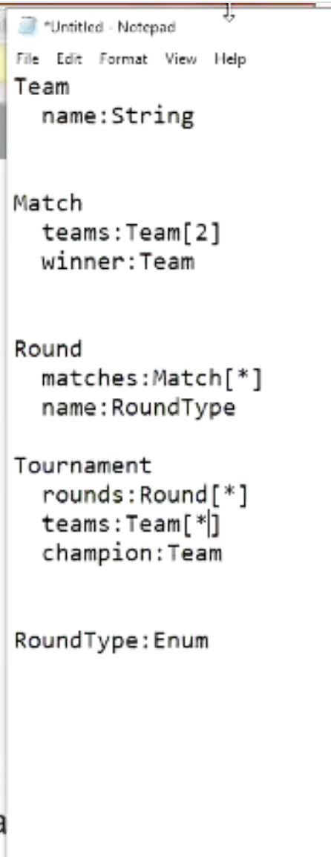

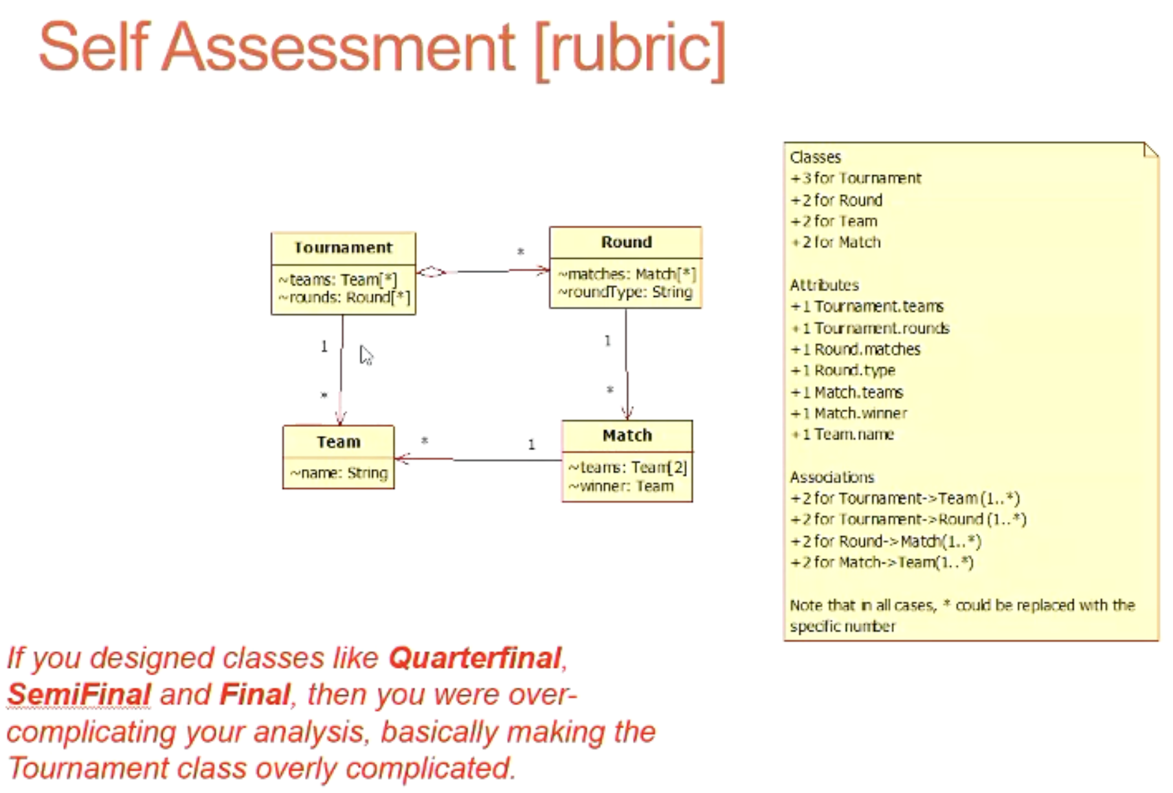

Trying to understand the state, cardinality and multiplicity between the different classes

**Final exam question #1 will be about use cases, and #2 will be a class diagram**

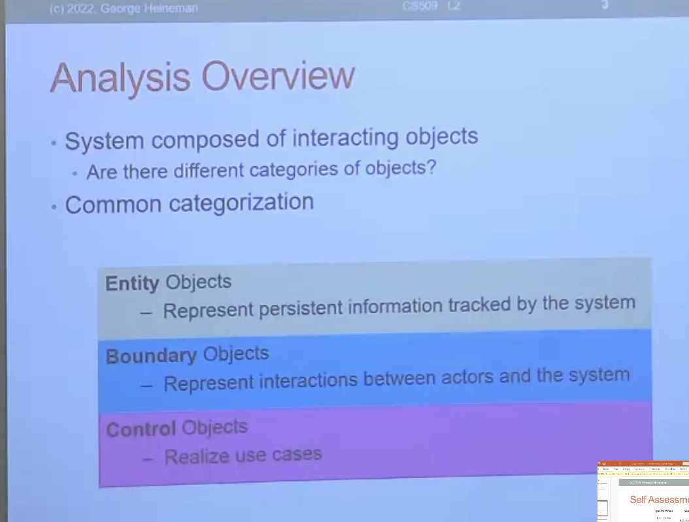

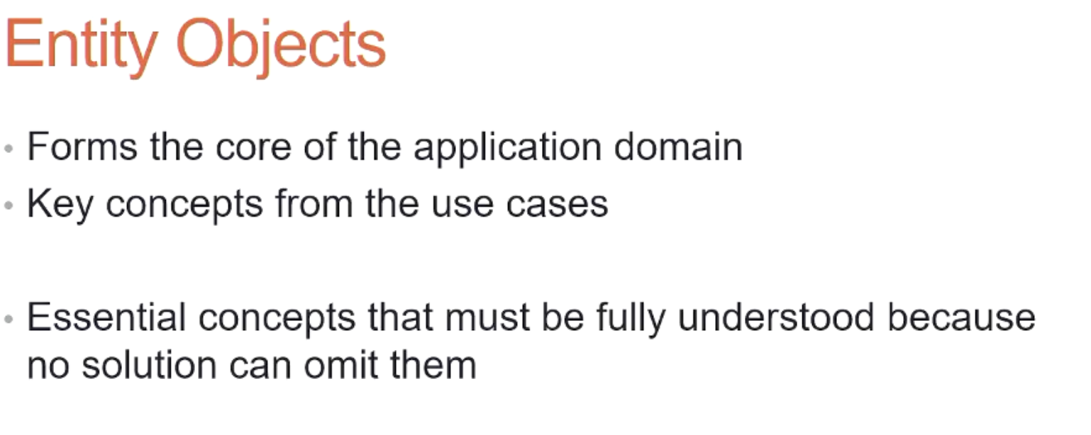

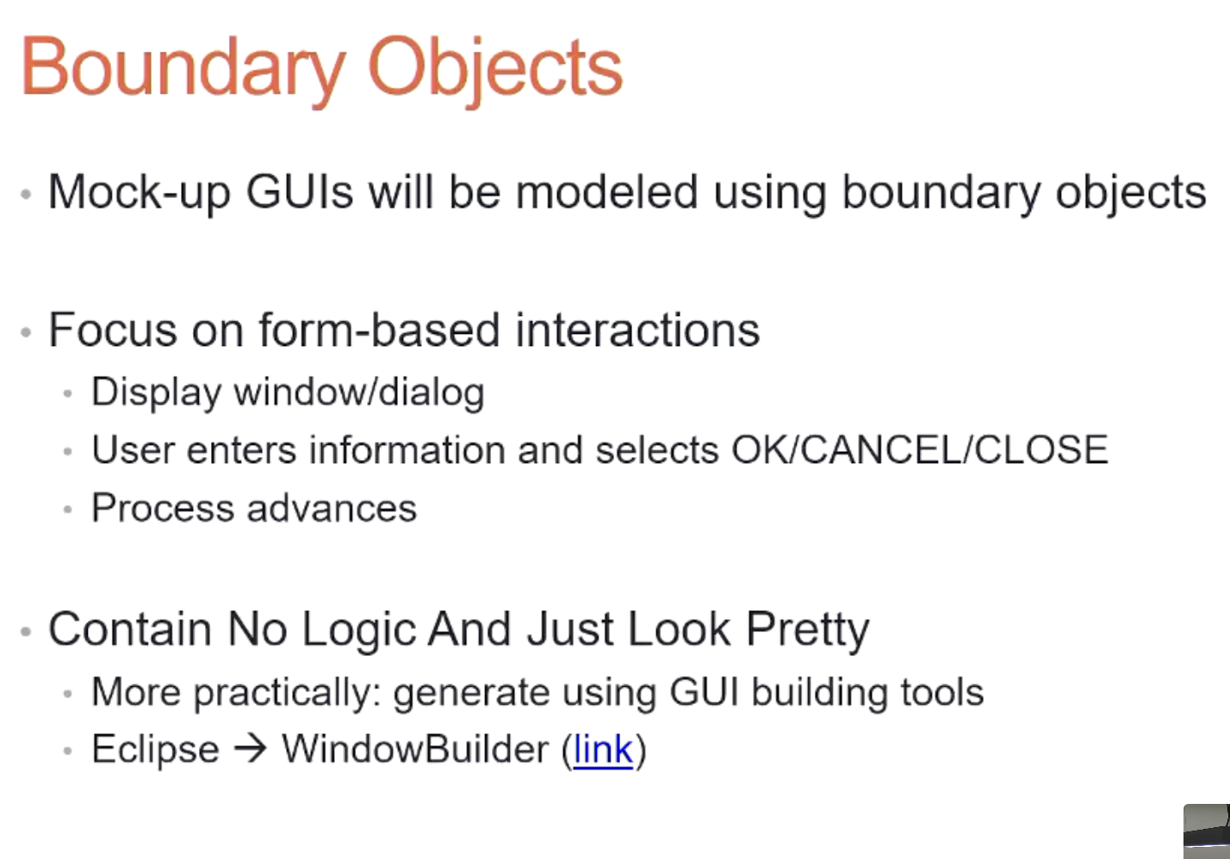

**Boundaries have no state or logic, they just render the state**

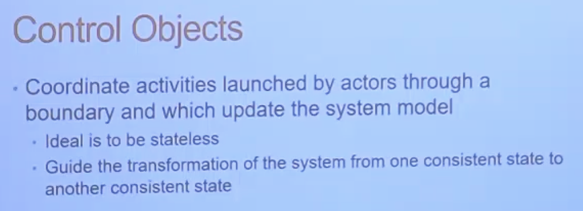

**Controller objects manipulate the entity objects**

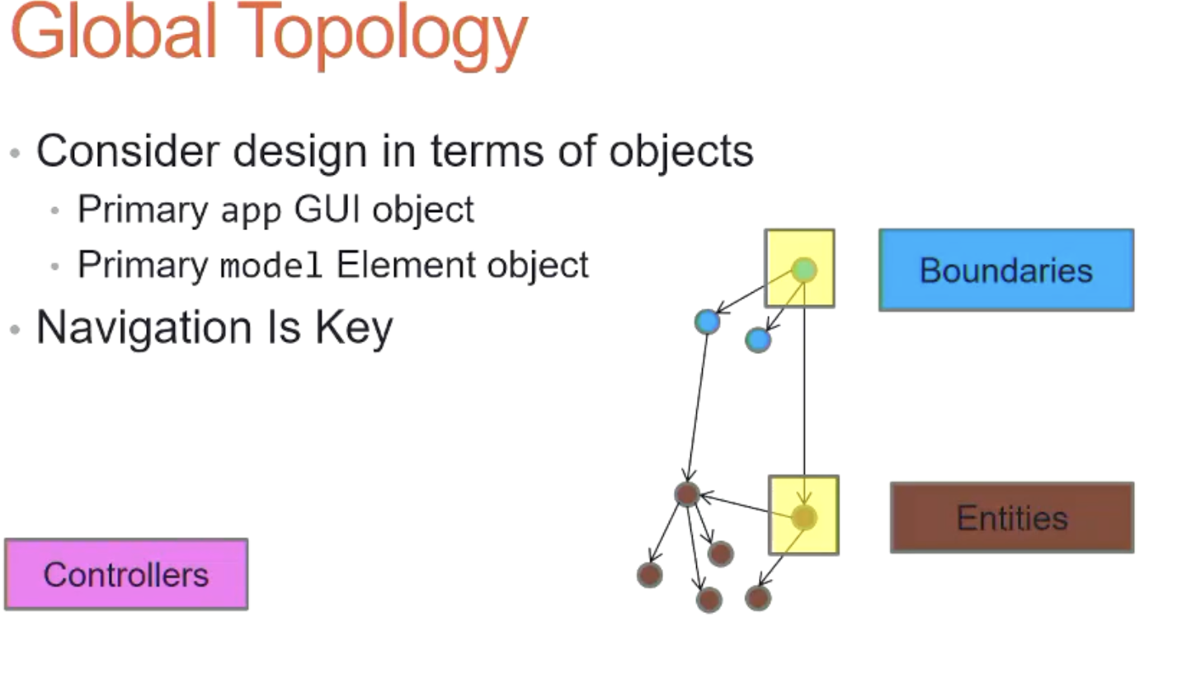

**Top level GUI object = Boundary**

**The DOM in javascript webpages could be considered a Top level object**

**Top Level Entity(Model) object**

**Controllers needs to know about the top level entity**

**Controllers also need to communicate with boundaries to make sure theyre refreshed.**

**In javascript controllers end up being simple functions**

